The Sunday Witness
The Weekly Bulletin of Holy Apostles
Orthodox Christian Church of Cheyenne
August 30, 2015 – The 13th Sunday of Matthew

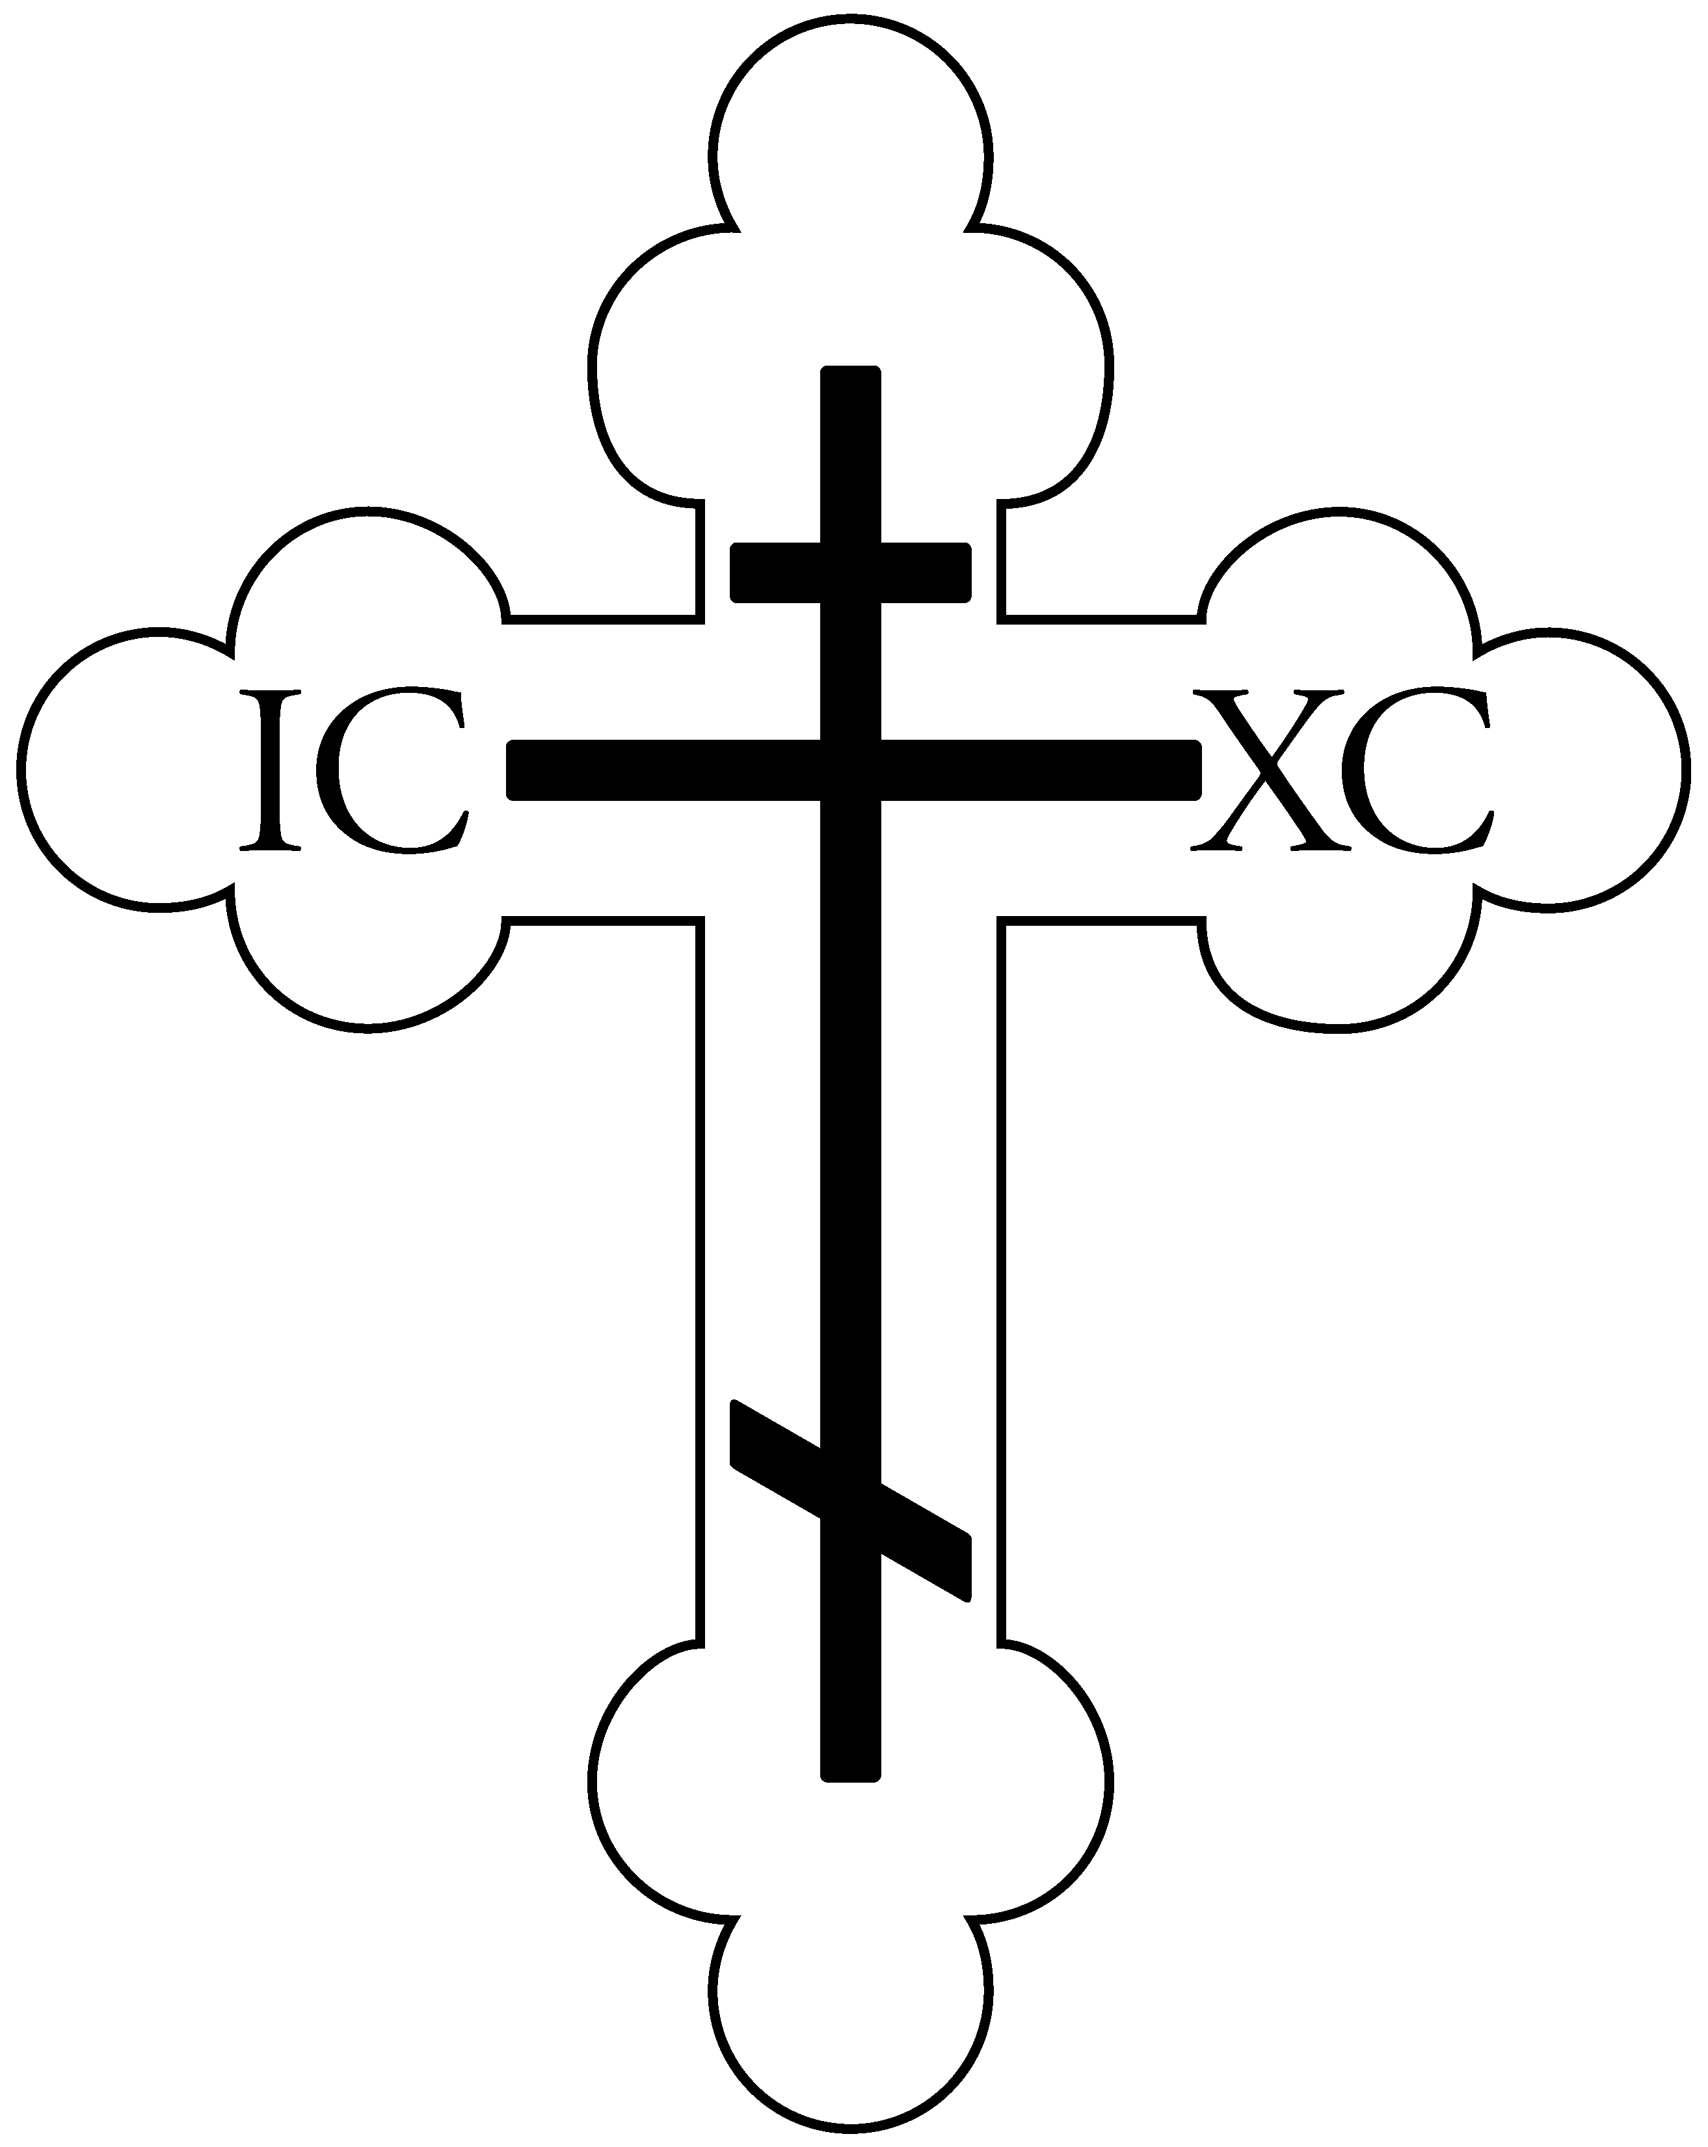

Commemorated Today
Apodosis of the Feast of the Forerunner
Alexander, John, and Paul the New, Patriarchs of Constantinople
Phantinos the Righteous of Calabria
16 Monk-Martyrs of Thebes
6 Martyrs of Melitene
Synaxis of the Holy Hierarchs of Serbia
The Holy New Martyrs of Serbia

Today’s Hymns
(to be chanted for pages 16 & 17 of the Liturgy Book)
Apolytikion for the Resurrection (Appendix 4): When the women Disciples of the Lord had learned from the Angel the joyful message of the Resurrection and had rejected the ancestral decision, they cried aloud to the Apostles triumphantly: Death has been despoiled, Christ God has risen, granting His great mercy to the world.

Apolytikion for the Forerunner: The memory of the just is observed
with hymns of praise; for you suffices the testimony of the Lord, O Forerunner. You have proved to be truly more ven'rable
than the Prophets, since you were granted to baptize in the river the One whom they proclaimed. Therefore, when for the truth you had contested, rejoicing, to those in Hades you preached the Gospel, that God was manifested in the flesh, and takes away the sin of the
world, and grants to us the great mercy.

For the Parish: O Holy Apostles, intercede with the Merciful God, that He grant unto our souls forgiveness of offenses.

Kontakion: Both Joachim and Anna from their sterility's stigma, and Adam and Eve from their mortality's ruin have been set free, O immaculate Maid, by your holy nativity. For this do your people hold celebration, redeemed from the guilt of transgression as they cry to you, "The barren one bears the Theotokos, the nourisher of our Life."
Today’s Epistle Reading

Cantor: O Lord, how manifold are your works. You have made all things in wisdom.

Bless the Lord, O my soul.

The Reading is from St. Paul's First Letter to the Corinthians (16:13-24)

BRETHREN, be watchful, stand firm in your faith, be courageous, be strong. Let all that you do be done in love. Now, brethren, you know that the household of Stephanas were the first converts in Achaia, and they have devoted themselves to the service of the saints; I urge you to be subject to such men and to every fellow worker and laborer. I rejoice at the coming of Stephanas and Fortunatus and Achaicos, because they have made up for your absence; for they refreshed my spirit as well as yours. Give recognition to such men. The churches of Asia send greetings. Aquila and Prisca, together with the church in their house, send you hearty greetings in the Lord. All the brethren send greetings. Greet one another with a holy kiss. I, Paul, write this greeting with my own hand. If any one has no love for the Lord, let him be accursed. Our Lord, come! The grace of the Lord Jesus be with you. My love be with you all in Christ Jesus. Amen.

Gospel Reading

The Reading is from the Gospel of Matthew (21:33-42)

The Lord said this parable, "There was a householder who planted a vineyard, and set a hedge around it, and dug a wine press in it, and built a tower, and let it out to tenants, and went into another country. When the season of fruit drew near, he sent his servants to the tenants, to get his fruit; and the tenants took his servants and beat one, killed another, and stoned another. Again he sent other servants, more than the first; and they did the same to them. Afterward he sent his son to them, saying 'They will respect my son.' But when the tenants saw the son, they said to themselves, 'This is the heir; come, let us kill him and have his inheritance.' And they took him and cast him out of the vineyard and killed him. When therefore the owner of the vineyard comes, what will he do to those tenants?" They said to him, "He will put those wretches to a miserable death, and let out the vineyard to other tenants who will give him the fruits in their seasons." Jesus said to them, "Have you never read in the scriptures: 'The very stone which the builders rejected has become the head of the corner; this was the Lord's doing, and it was marvelous in our eyes?'"

Welcome Visitors!

Holy Apostles Orthodox Christian Church would like to extend a warm welcome to all of our guests and visitors who are with us today. Thank you for worshiping with us, and please stay for Coffee Hour at the conclusion of the Liturgy! If you have any questions about this parish, the service, or the Orthodox Church in general, please feel free to ask a parishioner, look at the pamphlets in the Narthex (the entrance to the church), or ask Fr. Paul after the service. Finally, if this is your first visit to our parish, in order that we may treat you as our honored guest, we ask that you not participate in the offering after the service. Again, thank you for joining us, and let us know if we can do anything for you today or in the future!

A Note on Holy Communion

For non-Orthodox: Welcome to our parish and the service of the Divine Liturgy! As a point of information, the Orthodox Church invites all to come and participate in the Divine Services. As the fullest communion among people occurs only when we are wholly united in faith and worship, however, please know that the Mystery of Holy Communion is reserved for Baptized/Chrismated Orthodox Christians. If, at the time of Holy Communion, you would like to receive a blessing from the Priest, we welcome you to approach the Chalice with those receiving Communion and recite the words, “The blessing of the Chalice” to the Priest who will then offer a blessing over your head. Further, at the conclusion of the Liturgy, ALL are welcome (Orthodox and non-Orthodox) to receive a piece of the blessed bread given out by the Priest. And please stay for our fellowship hour following the Liturgy!

For Orthodox: Holy Communion is reserved for those who have properly prepared through prayer, fasting, and the Mystery of Holy Confession and have arrived prior to the Gospel for the day, remembering the teachings of St. Paul which tell us that receiving Holy Communion unworthily is to our condemnation rather than salvation (I Cor 11:29). When receiving Holy Communion, please remove any lipstick prior to approaching the Chalice and hold the Communion cloth with both hands against the bottom of your chin. Finally, please refrain from venerating the Chalice after receiving.
This Week at Holy Apostles…

Monday, 8/31 – 5:30pm Media Monday (The Good Wife – pt 3)
Tuesday, 9/1 – 7:00am Men’s Group
8:45 Orthros, 9:30 Liturgy – New Ecclesiastical Year
Wednesday, 9/2 – 6:00pm Paraklesis
Saturday, 9/5 – 6:00pm Great Vespers

Thank you...

Stacey for your offerings of Prosfora, Stephan & Kay for hosting today’s fellowship, Sarah for greeting, and all of the chanters who helped today and throughout the week!

Some Words from a Saint/Elder...

“Let us turn back and speak of the same things again. Let us consider how each day we eat bread and drink water, yet on the morrow our bodies need drink and food again. In like manner the recollection of God’s bounties never wearies the soul but disposes her still more to think on God. Or again: the more wood you pile on a fire, the more heat you get, and thus it is with God – the more you think on Him, the more you are fired with love and fervor towards Him.”

“The Holy Spirit is very much like a deer mother. A mother loves her child and has pity on it; and the holy spirit likewise has pity on us, forgive us and heals us, and likens and rejoices us. And the Holy Spirit is to be known through humble prayer.”

- St Silouan the Athonite (+1938)

Future Dates to Keep in Mind

Thursday, 9/10 – Next PC Meeting
Sunday, 9/13 – First Day of Sunday School
Stewardship Education Kickoff
First HAYA meeting
Monday, 9/14 – 5:00pm Fundraising Meeting
Sunday, 10/11 – General Assembly after Liturgy
Sunday, 11/1 – Stewardship Sunday
Saturday, 11/14 – Open House & Car Raffle Drawing
Thank you to those who have been
Selling their raffle tickets!!!

Holy Apostles Orthodox Christian Church
9505 Hynds Blvd, Cheyenne, WY 82009
www.holyapostlescheyenne.com
Presiding Priest: Fr. Paul Truebenbach Phone: 307-331-5197

