The Sunday Witness
The Weekly Bulletin of Holy Apostles
Orthodox Christian Church of Cheyenne
August 2, 2015 – The 9th Sunday of Matthew

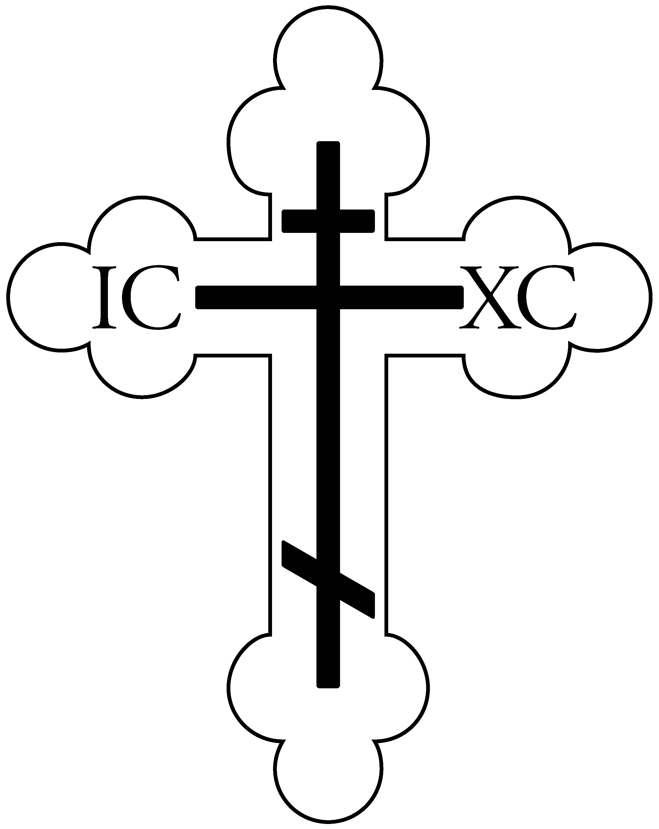

Commemorated Today
Translation of the Relics of Stephen the Protomartyr
Holy Glorious New Martyr Theodore of Dardenelles
Phocas the Martyr

Today’s Hymns
(to be chanted for pages 16 & 17 of the Liturgy Book)
Apolytikion for the Resurrection (Appendix 8): You descended from on high, O compassionate One, and condescended to be buried for three days, so that from the passions You might set us free. Our life and resurrection, O Lord, glory be to You.

Apolytikion for the Protomartyr: O Stephen, a crown of royalty was laid on your head for contests you courageously endured for Christ our God, as first among Martyr saints. You stood in accusation of the raging Judeans; and you saw your Savior at the right hand of the Father. We pray that you will ever entreat Him to save our souls.

For the Parish: O Holy Apostles, intercede with the Merciful God, that He grant unto our souls forgiveness of offenses.

Kontakion: Upon the mountain were You transfigured, and Your disciples beheld Your glory as far as they were able, O Christ our God; so that when they would see You crucified they might understand that Your Passion was deliberate, and declare to the world that in truth You are the Father's radiance.
Today’s Epistle Reading

Cantor: Make your vows to the Lord our God and perform them.

God is known in Judah; his name is great in Israel.

The Reading is from the Acts of the Apostles (6:8-15; 7:1-5, 47-60)
IN THOSE DAYS, Stephen, full of grace and power, did great wonders and signs among the people. Then some of those who belonged to the synagogue of the Freedmen (as it was called), and of the Cyrenians, and of the Alexandrians, and of those from Cilicia and Asia, arose and disputed with Stephen. But they could not withstand the wisdom and the Spirit with which he spoke. Then they secretly instigated men, who said, "We have heard him speak blasphemous words against Moses and God." And they stirred up the people and the elders and the scribes, and they came upon him and seized him and brought him before the council, and set up false witnesses who said, "This man never ceases to speak words against this holy place and the law; for we have heard him say that this Jesus of Nazareth will destroy this place, and will change the customs which Moses delivered to us." And gazing at him, all who sat in the council saw that his face was like the face of an angel.

And the high priest said, "Is this so?" And Stephen said: "Brethren and fathers, hear me. The God of glory appeared to our father Abraham, when he was in Mesopotamia, before he lived in Haran, and said to him, 'Depart from your land and from your kindred and go into the land which I will show you.' Then he departed from the land of the Chaldeans, and lived in Haran. And after his father died, God removed him from there into this land in which you are now living; yet he gave him no inheritance in it, not even a foot's length, but promised to give it to him in possession and to his posterity after him, though he had no child.

"But it was Solomon who built a house for him. Yet the Most High does not dwell in houses made with hands; as the prophet says, 'Heaven is my throne, and earth my footstool. What house will you build for me, says the Lord, or what is the place of my rest? Did not my hand make all these things?'

"You stiff-necked people, uncircumcised in heart and ears, you always resist the Holy Spirit. As your fathers did, so do you. Which of the prophets did not your fathers persecute? And they killed those who announced beforehand the coming of the Righteous One, whom you have now betrayed and murdered, you who received the law as delivered by angels and did not keep it."

Now when they heard these things they were enraged, and they ground their teeth against him. But he, full of the Holy Spirit, gazed into heaven and saw the glory of God, and Jesus standing at the right hand of God; and he said, "Behold, I see the heavens opened, and the Son of man standing at the right hand of God." But they cried out with a loud voice and stopped their ears and rushed together upon him. Then they cast him out of the city and stoned him; and the witnesses laid down their garments at the feet of a young man named Saul. And as they were stoning Stephen, he prayed, "Lord Jesus, receive my spirit." And he knelt down and cried with a loud voice, "Lord, do not hold this sin against them." And when he had said this, he fell asleep.

Gospel Reading

The Reading is from the Gospel of Matthew (14:22-34)

At that time, Jesus made the disciples get into the boat and go before him to the other side, while he dismissed the crowds. And after he had dismissed the crowds, he went up into the hills by himself to pray. When evening came, he was there alone, but the boat by this time was many furlongs distant from the land, beaten by the waves; for the wind was against them. And in the fourth watch of the night he came to them, walking on the sea. But when the disciples saw him walking on the sea, they were terrified, saying, "It is a ghost!" And they cried out for fear. But immediately he spoke to them, saying "Take heart, it is I; have no fear."
And Peter answered him, "Lord, if it is you, bid me come to you on the water." He said, "Come." So Peter got out of the boat and walked on the water and came to Jesus; but when he saw the wind, he was afraid, and beginning to sink he cried out, "Lord, save me." Jesus immediately reached out his hand and caught him, saying to him, "O man of little faith, why did you doubt?" And when they entered the boat, the wind ceased. And those in the boat worshiped him, saying, "Truly you are the Son of God." And when they had crossed over, they came to land at Gennesaret.

Welcome Visitors!

Holy Apostles Orthodox Christian Church would like to extend a warm welcome to all of our guests and visitors who are with us today. Thank you for worshiping with us, and please stay for Coffee Hour at the conclusion of the Liturgy! If you have any questions about this parish, the service, or the Orthodox Church in general, please feel free to ask a parishioner, look at the pamphlets in the Narthex (the entrance to the church), or ask Fr. Paul after the service. Finally, if this is your first visit to our parish, in order that we may treat you as our honored guest, we ask that you not participate in the offering after the service. Again, thank you for joining us, and let us know if we can do anything for you today or in the future!

A Note on Holy Communion

For non-Orthodox: Welcome to our parish and the service of the Divine Liturgy! As a point of information, the Orthodox Church invites all to come and participate in the Divine Services. As the fullest communion among people occurs only when we are wholly united in faith and worship, however, please know that the Mystery of Holy Communion is reserved for Baptized/Chrismated Orthodox Christians. If, at the time of Holy Communion, you would like to receive a blessing from the Priest, we welcome you to approach the Chalice with those receiving Communion and recite the words, “The blessing of the Chalice” to the Priest who will then offer a blessing over your head. Further, at the conclusion of the Liturgy, ALL are welcome (Orthodox and non-Orthodox) to receive a piece of the blessed bread given out by the Priest. And please stay for our fellowship hour following the Liturgy!

For Orthodox: Holy Communion is reserved for those who have properly prepared through prayer, fasting, and the Mystery of Holy Confession and have arrived prior to the Gospel for the day, remembering the teachings of St. Paul which tell us that receiving Holy Communion unworthily is to our condemnation rather than salvation (I Cor 11:29). When receiving Holy Communion, please remove any lipstick prior to approaching the Chalice and hold the Communion cloth with both hands against the bottom of your chin. Finally, please refrain from venerating the Chalice after receiving.

This Week at Holy Apostles…

Sunday, 8/2 – 6:00pm Paraklesis
Monday, 8/3 – 9:30am Paraklesis (at SCH)
5:30pm Media Monday
Tuesday, 8/4 – 7:00am Men’s Group
5:00pm Conversing with the Fathers
6:00pm Paraklesis
Wednesday, 8/5 – 5:30pm Great Vespers
Thursday, 8/6 – 8:45 Orthros, 9:30 Liturgy – Holy Transfiguration
6:00pm Paraklesis (at SCH)
Friday, 8/7 – 6:00pm Paraklesis
Saturday, 8/8 – 6:00pm Paraklesis (at SCH)

Thank you...

Christine and Fay for your offerings of Prosfora, Driko & Christine for hosting fellowship, Tyler for greeting, and all of the chanters who helped today and throughout the week!

Some Words from a Saint/Elder...

“The man who cries out against evil men but does not pray for them will never know the grace of God.”
- St Silouan the Athonite (+1938)

Future Dates to Keep in Mind

Thursday, 8/13 – 4:30pm Next PC Meeting
Sunday, 8/16 – Anniversary Picnic after Liturgy (at HA)
Monday, 9/14 – 5:00pm Fundraising Meeting
Sunday, 10/11 – General Assembly after Liturgy
Sunday, 11/1 – Stewardship Sunday
Saturday, 11/14 – Open House & Car Raffle Drawing

Holy Apostles Orthodox Christian Church
9505 Hynds Blvd, Cheyenne, WY 82009
www.holyapostlescheyenne.com
Presiding Priest: Fr. Paul Truebenbach Phone: 307-331-5197

