The Sunday Witness
The Weekly Bulletin of Holy Apostles
Orthodox Christian Church of Cheyenne
July 26, 2015 – The 8th Sunday of Matthew

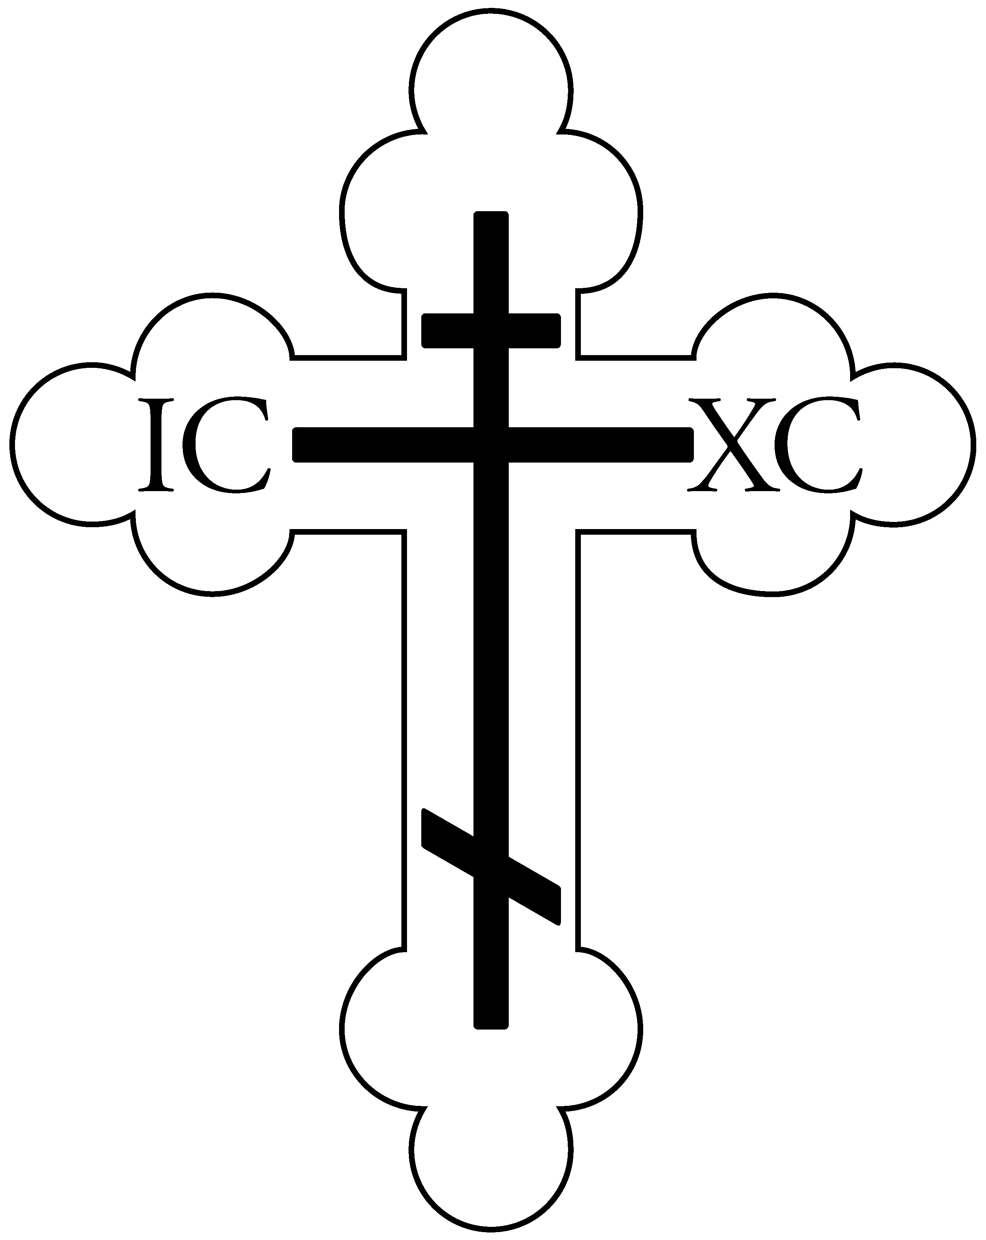

Commemorated Today
The Holy Hieromartyrs Hermolaus, Hermippus, and Hermacrates
Paraskevi, the Righteous Martyr of Rome
St. Prisca, the Righteous Martyr
Moses the Hungarian
Jacob Netsvetov, the Enlightener of Alaska

Today’s Hymns
(to be chanted for pages 16 & 17 of the Liturgy Book)
Apolytikion for the Resurrection (Appendix 6): When the angelic powers appeared at Your grave, the soldiers guarding it feared and became as dead. And standing by the sepulcher was Mary who was seeking Your immaculate body. You devastated Hades, not afflicted by it. You went to meet the virgin, and granted eternal life. You resurrected from the dead. O Lord, glory to You.

Apolytikion for the Fathers: Supremely blessed are You, O Christ our God. You established the holy Fathers upon the earth as beacons, and through them You have guided us all to the true Faith, O greatly merciful One, glory be to You.

For the Parish: O Holy Apostles, intercede with the Merciful God, that He grant unto our souls forgiveness of offenses.

Kontakion: A protection of Christians unshamable, intercessor to our holy Maker, unwavering, reject not the prayerful cries of those who are sin; instead, come to us for you are good; your loving help bring unto us, who are crying in faith to you: hasten to intercede, and speed now to supplicate, as a protection for all time, Theotokos for those who honor you.

Today’s Epistle Reading

Cantor: God is wonderful among his saints.

Bless God in the congregations.

The Reading is from St. Paul's Letter to the Galatians (3:23-29; 4:1-5)

BRETHREN, before faith came, we were confined under the law, kept under restraint until faith should be revealed. So that the law was our custodian until Christ came, that we might be justified by faith. But now that faith has come, we are no longer under a custodian; for in Christ Jesus you are all sons of God, through faith. For as many of you as were baptized into Christ have put on Christ. There is neither Jew nor Greek, there is neither slave nor free, there is neither male nor female; for you are all one in Christ Jesus. And if you are Christ's, then you are Abraham's offspring, heirs according to promise. I mean that the heir, as long as he is a child, is no better than a slave, though he is the owner of all the estate; but he is under guardians and trustees until the date set by the father. So with us; when we were children, we were slaves to the elemental spirits of the universe. But when the time had fully come, God sent forth his Son, born of a woman, born under the law, to redeem those who were under the law, so that we might receive adoption as sons.

Gospel Reading

The Reading is from the Gospel of Matthew (14:14-22)

At that time, Jesus saw a great throng; and he had compassion on them, and healed their sick. When it was evening, the disciples came to him and said, "This is a lonely place, and the day is now over; send the crowds away to go into the villages and buy food for themselves." Jesus said, "They need not go away; you give them something to eat." They said to him, "We have only five loaves here and two fish." And he said, "Bring them here to me." Then he ordered the crowds to sit down on the grass; and taking the five loaves and the two fish he looked up to heaven, and blessed, and broke and gave the loaves to the crowds. And they all ate and were satisfied. And they took up twelve baskets full of the broken pieces left over. And those who ate were about five thousand men, besides women and children. Then he made the disciples get into the boat and go before him to the other side, while he dismissed the crowds.

Welcome Visitors!

Holy Apostles Orthodox Christian Church would like to extend a warm welcome to all of our guests and visitors who are with us today. Thank you for worshiping with us, and please stay for Coffee Hour at the conclusion of the Liturgy! If you have any questions about this parish, the service, or the Orthodox Church in general, please feel free to ask a parishioner, look at the pamphlets in the Narthex (the entrance to the church), or ask Fr. Paul after the service. Finally, if this is your first visit to our parish, in order that we may treat you as our honored guest, we ask that you not participate in the offering after the service. Again, thank you for joining us, and let us know if we can do anything for you today or in the future!

A Note on Holy Communion

For non-Orthodox: Welcome to our parish and the service of the Divine Liturgy! As a point of information, the Orthodox Church invites all to come and participate in the Divine Services. As the fullest communion among people occurs only when we are wholly united in faith and worship, however, please know that the Mystery of Holy Communion is reserved for Baptized/Chrismated Orthodox Christians. If, at the time of Holy Communion, you would like to receive a blessing from the Priest, we welcome you to approach the Chalice with those receiving Communion and recite the words, “The blessing of the Chalice” to the Priest who will then offer a blessing over your head. Further, at the conclusion of the Liturgy, ALL are welcome (Orthodox and non-Orthodox) to receive a piece of the blessed bread given out by the Priest. And please stay for our fellowship hour following the Liturgy!

For Orthodox: Holy Communion is reserved for those who have properly prepared through prayer, fasting, and the Mystery of Holy Confession and have arrived prior to the Gospel for the day, remembering the teachings of St. Paul which tell us that receiving Holy Communion unworthily is to our condemnation rather than salvation (I Cor 11:29). When receiving Holy Communion, please remove any lipstick prior to approaching the Chalice and hold the Communion cloth with both hands against the bottom of your chin. Finally, please refrain from venerating the Chalice after receiving.
This Week at Holy Apostles…

Sunday, 7/26 – SJCCL 3 – On the Lord’s Prayer
Monday, 7/27 – 8:45 Orthros, 9:30 Liturgy – St. Panteleimon the
Great Martyr and Unmercenary
5:30pm Media Monday
Tuesday, 7/28 – 7:00am Men’s Group
5:30pm Ministry Team Leaders meeting
Wednesday, 7/29 – 6:00pm Paraklesis
Thursday, 7/30 – 12:30pm Women’s Study Group
Saturday, 8/1 – 6:00pm Great Vespers

Thank you...

Christine for your offerings of Prosfora, Steven & Kelly for hosting fellowship, Nancy for greeting, and all of the chanters who helped today and throughout the week!

Some Words from a Saint/Elder...

"When I used to go to Fr. Tychon for Confession, I wouldn’t have anything serious to confess; and he would advise me, ‘There is sand, my son, there is sand!’ The little sins accumulate and add up to make a sand dune that is heavier than any single big stone. Someone who commits one big sin thinks of it all the time, repents and is humbled. You have a myriad of small sins. But if you examine the conditions under which you were raised, and the conditions under which the other person was raised, you will see that you are worse off spiritually than the other person.”

- St. Paisios the New of Mount Athos (+1994)

Future Dates to Keep in Mind

Tuesday, 7/28 – 5:30pm Ministry Heads Meeting
Thursday, 8/13 – 4:30pm Next PC Meeting
Sunday, 8/16 – Anniversary Picnic after Liturgy (at HA)
Sunday, 10/11 – General Assembly after Liturgy
Sunday, 11/1 – Stewardship Sunday
Saturday, 11/14 – Open House & Car Raffle Drawing

Holy Apostles Orthodox Christian Church
9505 Hynds Blvd, Cheyenne, WY 82009
www.holyapostlescheyenne.com
Presiding Priest: Fr. Paul Truebenbach Phone: 307-331-5197

